- Setup GitHub:
Below is Github link to our RWA projects repository.

https://github.com/joey5x2/RWA_Projects.git

To setup working folder for shared Github project in your local PC.
- Download and install Git https://git-scm.com/install/windows
- Open command window in your PC and cd to your working folder created
- Run the following Git command: git clone https://github.com/joey5x2/RWA_Projects.git
- Attached is the git commands cheat sheet

- Install Python version 3.13.5

- Setup VS Code Environment:
- Select Run command
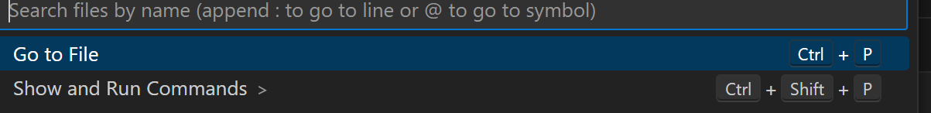
- Create virtual environment
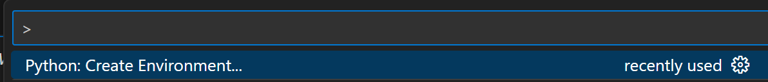
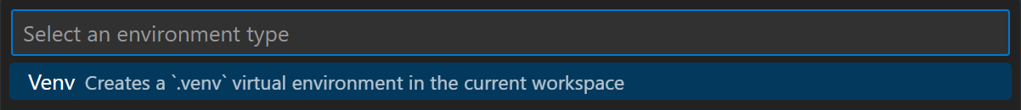
- Activate virtual environment
  - Open terminal in VS Code. In case virtual environment is not activated, run the following command: .venv\Scripts\activate

- Setup Anthropic Claude API
- Create Anthropic API key from: https://platform.claude.com/settings/keys
- Copy Anthropic API key and create Windows user environment variable: ANOTHRPIC_API_KEY

- Setup Streamlit UI package
- Install Streamlit package: pip install steamlit
- Execute streamlit: streamlit run rwa_explain.py

